**WVD Profile Disk Migration**

**Prerequisites:**

1. A server with Nested Hyper-v (It will be best to resize current VM that is serving as a fileserver)
2. Hyper-V Powershell Module
3. WVD disk Migration script. Script = “Migrate-wvdvhdx.ps1”
4. Azure Files with On-Prem Active Directory Domain Services configured properly
5. User account with Domain Admin rights and at least “Storage File Data SMB Share Elevated Contributor” Role assignment to the storage account
6. Storage access key to the storage account

**Goal:**

RDS Windows Native Profile Disk and FSLogix have 2 different profile structures. So the goal is to convert and modify the current .vhd and configure it to the new structure for FSLogix. In the below picture we want to migrate everything under the “profile” directory and add a registry setting within the user’s profile folder. Everything under H in the left picture got moved into the .\Profile folder on the right

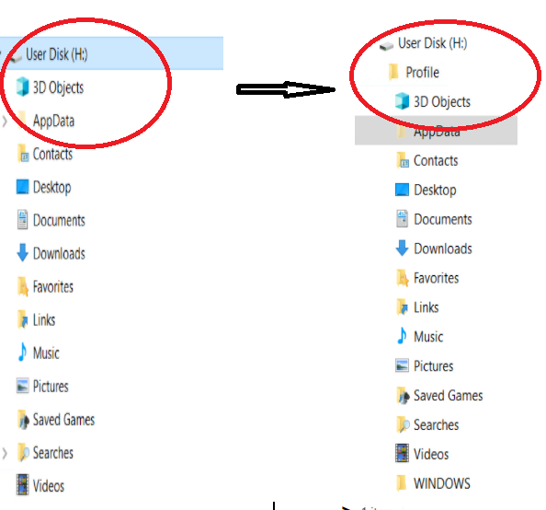

**Process:**

1. Create a group policy setting for fslogix to use the same disk naming format as well as the location of where the drives are to be located.
2. Shutdown the Storage Host Server and wait until it is deallocated
3. Resize it to a F-Series or even an E-Series VM. Normally a F4v2 is fine.
4. Turn on the Vm and add the hyper-v service, this will give you the hyper-v powershell module as well, Reboot when promoted.

WARNING! DO NOT bind the network adapter to hyper-v or you will not be able to reconnect.

1. Open the script in powershell ISE and fill in the blanks
2. Run script

Below is the script process

* 1. Mount the current RDS drive
  2. Create a folder named Profile
  3. Move all existing profile folders tinder Profiles
  4. Create a Registry file under each user’s \Profile\AppData\Local\FSLogix folder and named Profiledata.reg
  5. Unmount the disk
  6. Copy the disk to the Destination Folder of the GPO location of the disk
  7. Set Permissions for the user to own their own disk

**Finished! This script automates this process, if everything else is set up correctly.**